Lab 8 – Forms and Session State

# Purpose

* Forms
* Various ‘input’ Tags
* Session State
* Upload your website to a Web server

# Due Date

* This lab is must be handed in:

**Friday Mar 29, 2019 – before midnight**

# Assessment

* This Lab is worth 2% of your total course mark.

# Assigned Readings

The following chapters of ‘Fundamentals of Web Development’ will be useful in completing this exercise:

* Chapter 13.6

# Lab Supplies

To complete this lab you will require the following lab supplies:

* Textbook: Fundamentals of Web Development
* EasyPHP, or other WAMP server
* Eclipse, Notepad (or other text editor, or IDE)
* FileZilla (or other FTP client)

# Summary of Tasks

1. Develop the logic to display your web application
2. Upload your website to the webserver
3. View your webpage using a web browser
4. Submit Assignment Link on Brightspace
5. Submit Source Code of all PHP files on Brightspace

# Task 1

Before getting started with the following tasks, review the ‘Common Look and Feel’ video provided on Brightspace (under: Course Content 🡪 Extra Materials). Using the knowledge gained in these materials, implement the following Design Pattern to create a ‘Common Look and Feel’ to be used on every page of your website.

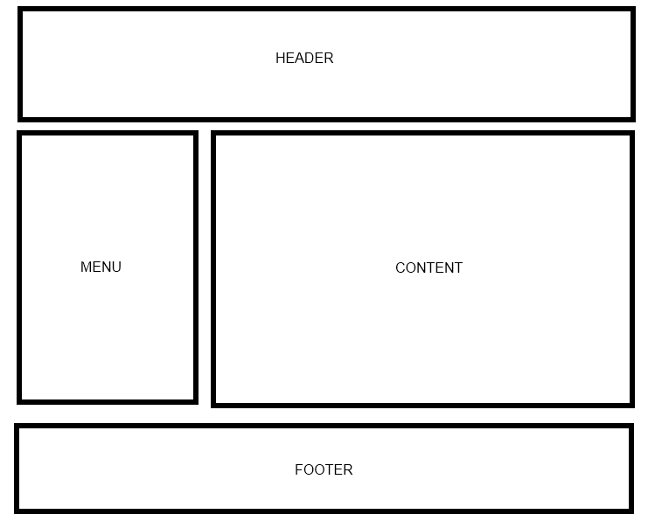

Your web site will include the following PHP scripts:

* Header.php
* Footer.php
* Menu.php
* Input.php
* Session1.php
* Session2.php

**NOTE: Input.php, Session1.php, Session2.php all must include the Common look and feel implemented in Header.php, Footer.php and Menu.php.**

**Header.php**

Header.php must contain a script to display a Common Header that will appear on every page. The header must contain a banner (images, css, etc).

**Footer.php**

Footer.php must contain a script to display a Common Footer that will appear on every page. The footer must contain Student Number, First Name, Last Name, and Email Address

**Menu.php**

Menu.php must contain a script to display a Common Menu to be show on every page. The menu must contain links to Input.php, Session1.php and Session2.php

**Input.php**

Create a PHP script that will perform the following tasks:

1. Divide the content area of this page into two sections (Side by Side)
2. On the left side: create a form that accepts the following information from the user
   1. Text box (input type="text"), First Name
   2. Text box (input type="text"), Last Name
   3. Text box (input type="number"), Telephone Number
   4. Text box (input type="email"), Email
   5. Text box (input type="date"), Birth Day
   6. Radio Button, with the values Student, Doctor, Farmer and Engineer
   7. Select, a multiple select box that lists favourite sports (e.g., Hockey, Football, Carling, Tennis)
   8. Submit button with the text ‘Submit’
   9. Reset button with the text ‘Reset’

The form on the left side MUST be designed as below:

|  |
| --- |
|  |

1. On the right side: When the user clicks ‘Submit’, it should gather all the information from the form on the left side and display the results on the right side

**Session1.php**

Create a PHP script that will perform the following tasks:

1. Implement the same form listed in **Input.php**
2. This time, when the user clicks ‘Submit’ , it should store all the information gathered from the form in the session state
3. Automatically Redirect the user to Session2.php

**Session2.php**

Once the user is forwarded to Session2.php, display the results of the information gathered from the session state of the form Session1.php.

**NOTE: Forms, Session_RetrieveValues.php, Session_StoreValues.php (Posted on Brightspace) provide examples of how to do all of these things.**

# Task 2

Upload your website to the Web server. Use an FTP client to connect to your Web server.

Once you connect to the webserver using an FTP client, create a directory called ‘/CST8238/Lab8’. Once your course directory has been created navigate to that new directory. Add your Input.php file to this location. (Using FileZilla simply drag the Input.php file into your folder). Add all of your PHP files to this location.

# Task 3

View your website using a web browser. Open a web browser and navigate to the following web address:

**http://web-server_domain_name/CST8238/Lab8/<filename>**

For example, the web address to my page is:   
  
http://profrejaul.com/CST8238/Lab8/Input.php

Where ‘profrejaul.com’ is the domain name of the Web server, ‘ /CST8238/Lab8’ is the name of the directory I created in the Web server using FTP client and ‘Input.php’ is the home page I created for this lab.

# Task 4

Once you have confirmed that your webpage is available online, you are ready to hand in your lab.

Create a compressed file (**Lab8.zip**) which will contain the following PHP files:

* Header.php
* Footer.php
* Menu.php
* Input.php
* Session1.php
* Session2.php

Create a word document (**Lab8.doc**) in which write the following Information:

* Student Number
* First Name
* Last Name
* The URL, or hyperlink of the home page (Input.php) of Lab 8

To hand in your lab, go to Brightspace and navigate to *Course Content 🡪* Labs and click on ‘Lab 8 – Forms and Session State’ link.

Upload the word document (**Lab8.doc**) and the compressed file **(Lab8.zip**) on Brightspace.

Finally, click the ‘Submit’ button to send the lab to your professor.

N.B. Please keep in mind that ONLY .**zip** file is accepted as the format of the compressed file.

**IMPORTANT NOTE**:

If the URL, or hyperlink, does not direct the professor to the lab you will receive a ZERO for the lab assignment.

**IMPORTANT NOTE:**

You may only submit a Lab ONE TIME. Be sure the lab is complete before clicking on the ‘Submit’ button.